### **Noman Khan Day 2 Assingments**

### **Assignment 1**: SDLC Overview - Create a one-page infographic that outlines the SDLC phases (Requirements, Design, Implementation, Testing, Deployment), highlighting the importance of each phase and how they interconnect.

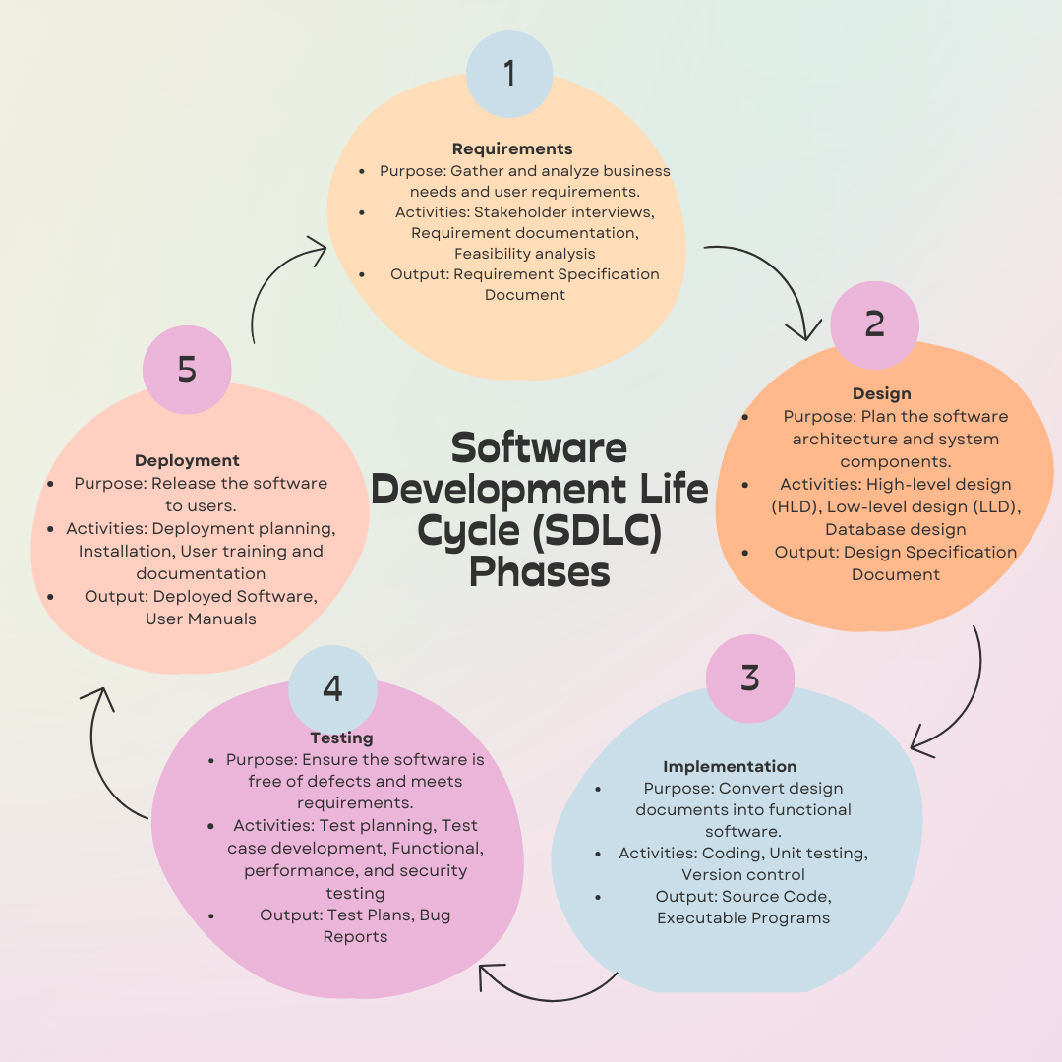

### 

### 

### Software Development Life Cycle (SDLC) Phases

#### 1. Requirements

* Purpose: Gather and analyze business needs and user requirements.
* Key Activities:
  + Stakeholder interviews
  + Requirement documentation
  + Feasibility analysis
* Importance: Establishes a clear understanding of what the software needs to achieve.
* Output: Requirement Specification Document

#### 2. Design

* Purpose: Plan the software architecture and system components.
* Key Activities:
  + High-level design (HLD)
  + Low-level design (LLD)
  + Database design
* Importance: Provides a blueprint for developers, ensuring all components are well-planned.
* Output: Design Specification Document

#### 3. Implementation

* Purpose: Convert design documents into functional software.
* Key Activities:
  + Coding
  + Unit testing
  + Version control
* Importance: Develops the actual software product based on design specifications.
* Output: Source Code, Executable Programs

#### 4. Testing

* Purpose: Ensure the software is free of defects and meets requirements.
* Key Activities:
  + Test planning
  + Test case development
  + Functional, performance, and security testing
* Importance: Verifies and validates the software’s functionality, performance, and security.
* Output: Test Plans, Bug Reports

#### 5. Deployment

* Purpose: Release the software to users.
* Key Activities:
  + Deployment planning
  + Installation
  + User training and documentation
* Importance: Makes the software available to users, ensuring it operates in the intended environment.
* Output: Deployed Software, User Manuals

### Interconnections between Phases

* Requirements ↔ Design: Clear requirements guide the design; design reviews may refine requirements.
* Design ↔ Implementation: Detailed designs are implemented into code; issues during implementation may require design adjustments.
* Implementation ↔ Testing: Code is rigorously tested; testing feedback can lead to code changes.
* Testing ↔ Deployment: Successful testing results in deployment readiness; deployment issues may necessitate further testing.

### 

### 

### 

### 

### 

### 

### 

### **Assignment 2**: Assignment 2: Develop a case study analyzing the implementation of SDLC phases in a real-world engineering project. Evaluate how Requirement Gathering, Design, Implementation, Testing, Deployment, and Maintenance contribute to project outcomes.

### **Case Study: Implementing SDLC Phases in the Development of a Smart Home System**

#### Project Overview

The project involves developing a smart home system, which integrates various IoT devices to enhance home automation, security, and energy efficiency. The system includes features like smart lighting, thermostat control, security cameras, and voice-activated assistants.

### **SDLC Phases Analysis**

#### **1. Requirements Gathering**

Activities:

* Conducted interviews with potential users to understand their needs and preferences.
* Analyzed market trends and competitors’ products.
* Documented functional and non-functional requirements.

**Contribution to Project Outcomes:**

* Clear Scope: Defined project scope and objectives, ensuring all stakeholders were aligned.
* User-Centered Design: Focused on user needs and expectations, which guided subsequent phases and improved user satisfaction.
* Risk Mitigation: Identified potential risks early, allowing for proactive risk management strategies.

#### **2. Design**

Activities:

* Created high-level architecture designs, including hardware and software components.
* Developed detailed design documents for each system module.
* Conducted design reviews and iterations based on stakeholder feedback.

Contribution to Project Outcomes:

* Blueprint for Development: Provided a clear and detailed plan for developers, minimizing ambiguity and errors during implementation.
* Scalability and Flexibility: Ensured the design was modular, allowing for future expansion and integration of additional features.
* Quality Assurance: Design reviews helped catch potential issues early, reducing costly rework later in the project.

#### **3. Implementation**

Activities:

* Divided the project into manageable sprints using Agile methodology.
* Developed code for each module, adhering to coding standards and guidelines.
* Integrated hardware components with software modules.

Contribution to Project Outcomes:

* Efficient Development: Agile sprints allowed for iterative development, with regular reviews and adjustments.
* Quality Code: Adhering to coding standards ensured maintainability and reduced technical debt.
* Seamless Integration: Smooth integration of hardware and software components resulted in a cohesive and functional system.

#### **4. Testing**

Activities:

* Conducted unit testing for individual modules.
* Performed integration testing to ensure modules worked together correctly.
* Executed system testing to validate the overall functionality against requirements.
* Carried out user acceptance testing (UAT) with a group of beta testers.

Contribution to Project Outcomes:

* Bug-Free Product: Identified and resolved defects, ensuring a stable and reliable system.
* Validated Performance: Ensured the system met performance benchmarks and could handle expected loads.
* User Feedback: UAT provided valuable insights and allowed for final adjustments based on real user feedback.

#### **5. Deployment**

Activities:

* Developed a deployment plan, including timelines and resource allocation.
* Deployed the system in phases, starting with a pilot deployment.
* Provided training sessions and user manuals for end-users.
* Established a support team for handling initial issues post-deployment.

Contribution to Project Outcomes:

* Controlled Rollout: Phased deployment minimized disruptions and allowed for smooth transitions.
* User Readiness: Training and documentation ensured users could effectively utilize the system from day one.
* Immediate Support: A dedicated support team addressed initial issues quickly, maintaining user trust and satisfaction.

#### **6. Maintenance**

Activities:

* Set up a monitoring system to track system performance and usage.
* Regularly released updates and patches to fix bugs and add features.
* Provided ongoing customer support and handled user feedback for continuous improvement.

Contribution to Project Outcomes:

* Continuous Improvement: Regular updates and enhancements kept the system relevant and useful.
* High Reliability: Proactive maintenance reduced system downtime and maintained user satisfaction.
* User Engagement: Ongoing support and responsiveness to user feedback built a loyal customer base.

### 

### **Conclusion**

The implementation of the SDLC phases in the smart home system project ensured a structured and systematic approach to development. Each phase contributed significantly to the overall success of the project:

* Requirements Gathering established a solid foundation by aligning the project with user needs.
* Design provided a clear blueprint for implementation, ensuring a robust architecture.
* Implementation translated designs into a functional product efficiently and effectively.
* Testing ensured the system was reliable and met all specified requirements.
* Deployment facilitated a smooth transition to the end-users with minimal disruptions.
* Maintenance ensured the system remained reliable and up-to-date, maintaining user satisfaction over time.

### 

### 

### 

### 

### 

### 

### 

### 

### 

### 

### **Assignment 3:** Research and compare SDLC models suitable for engineering projects Present findings on waterfall, Agile, Spiral, and V-Model approaches, emphasizing their advantages, disadvantages and applicability in different engineering contexts

### **Research and Comparison of SDLC Models for Engineering Projects**

#### **1. Waterfall Model**

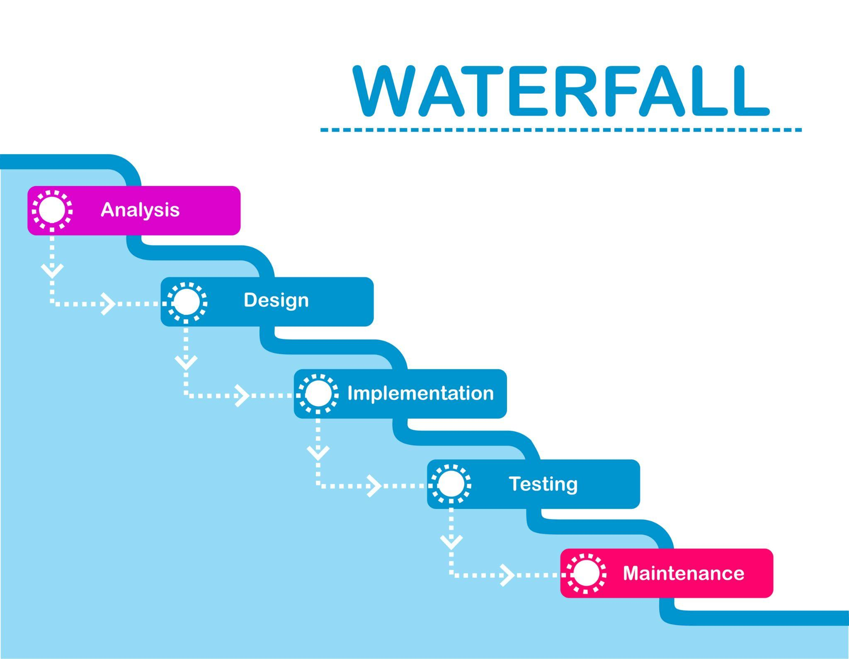

**Overview:** The Waterfall model is a linear and sequential approach where each phase must be completed before the next one begins. It follows a strict order: Requirements, Design, Implementation, Testing, Deployment, and Maintenance.

**Advantages:**

* **Structured Approach:** Clear and defined stages make project management straightforward.
* **Documentation:** Extensive documentation at each phase ensures clarity and thorough understanding.
* **Easy to Understand:** Simplicity and ease of use make it ideal for less complex projects.

**Disadvantages:**

* **Inflexibility:** Changes are difficult and costly to implement once the project is underway.
* **Late Testing:** Issues may not be discovered until the testing phase, leading to significant rework.
* **No Overlapping:** Phases do not overlap, which can lead to delays.

**Applicability:**

* **Best Suited For:** Projects with well-defined requirements and low uncertainty.
* **Examples:** Construction projects, manufacturing systems, and other projects where requirements are stable and well-understood from the beginning.

#### **2. Agile Model**

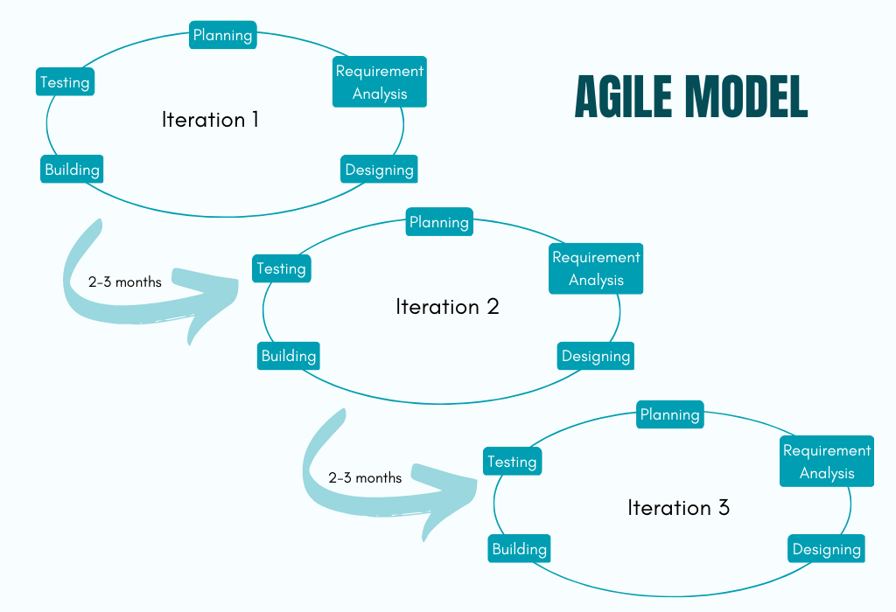

**Overview:** Agile is an iterative and incremental approach that emphasizes flexibility, customer collaboration, and rapid delivery. It is divided into small, manageable units called sprints, typically lasting 2-4 weeks.

**Advantages:**

* **Flexibility:** Easily accommodates changes in requirements and scope.
* **Customer Involvement:** Continuous customer feedback ensures the product meets user needs.
* **Frequent Deliveries:** Regularly delivers working software, providing value early in the project.

**Disadvantages:**

* **Less Predictability:** The flexible nature can lead to scope creep and less predictability in timelines and budgets.
* **Intensive Collaboration:** Requires significant time and involvement from stakeholders.
* **Documentation Can Be Neglected:** The focus on working software can sometimes result in insufficient documentation.

**Applicability:**

* **Best Suited For:** Projects with high uncertainty and evolving requirements.
* **Examples:** Software development, tech startups, and R&D projects where flexibility and customer feedback are crucial.

#### 

#### 

#### 

#### 

#### 

#### 

#### 

#### 

#### 

#### **3. Spiral Model**

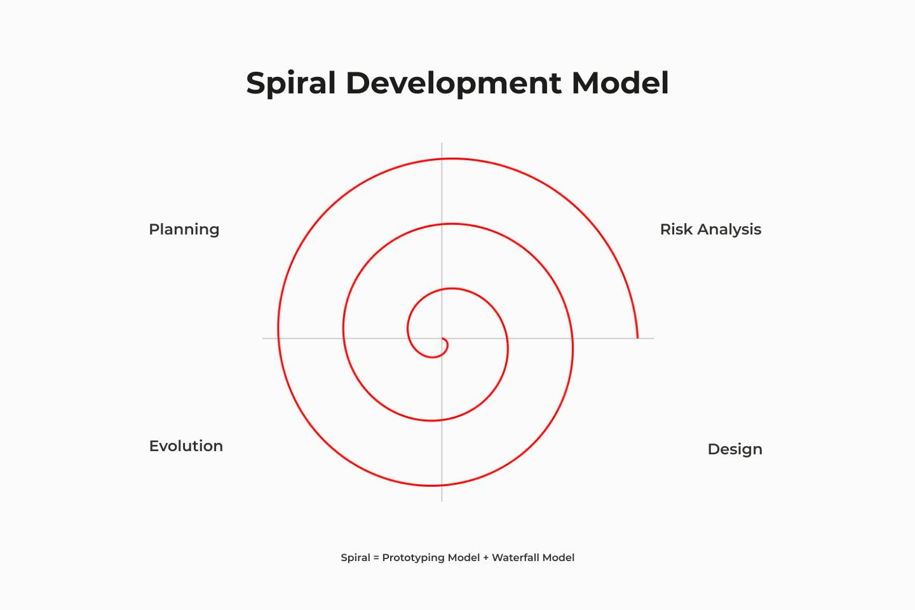

**Overview:** The Spiral model combines iterative development (prototyping) with systematic aspects of the Waterfall model. It emphasizes risk analysis and involves repeated cycles (or spirals) of planning, risk analysis, engineering, and evaluation.

**Advantages:**

* **Risk Management:** Focuses on risk assessment and mitigation throughout the project.
* **Iterative Development:** Allows for iterative refinement of requirements and solutions.
* **Flexibility:** Can adapt to changes and incorporate user feedback through multiple iterations.

**Disadvantages:**

* **Complexity:** Managing and planning multiple iterations can be complex and challenging.
* **Cost:** Can be more expensive due to repeated cycles and thorough risk analysis.
* **Time-Consuming:** Extensive planning and analysis phases can lengthen the project duration.

**Applicability:**

* **Best Suited For:** Large, complex, and high-risk projects requiring careful planning and risk management.
* **Examples:** Aerospace engineering, defense systems, and other critical systems where risk management is paramount.

#### 

#### **4. V-Model (Verification and Validation Model)**

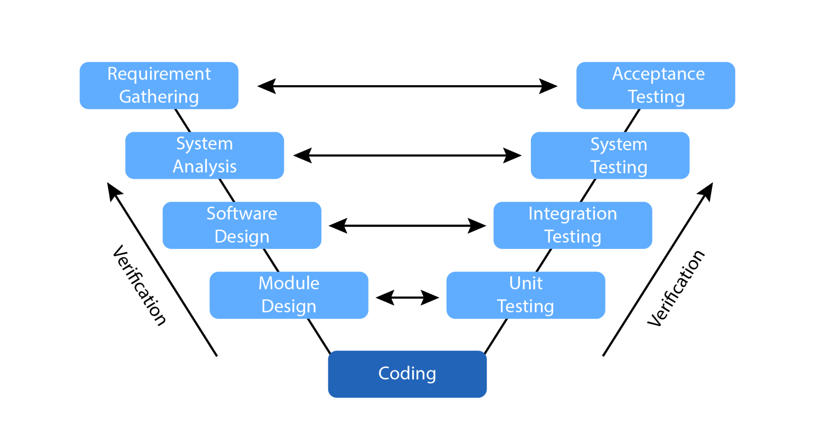

**Overview:** The V-Model is an extension of the Waterfall model that emphasizes verification and validation. It maps each development phase to a corresponding testing phase, forming a V-shape.

**Advantages:**

* **Parallel Testing:** Testing activities are planned in parallel with development phases, ensuring issues are caught early.
* **Clear Stages:** Each phase has a corresponding validation activity, providing a clear and structured process.
* **Quality Assurance:** Emphasizes quality through continuous verification and validation.

**Disadvantages:**

* **Rigid Structure:** Similar to the Waterfall model, it can be inflexible and challenging to accommodate changes.
* **Early Testing Dependency:** Early testing phases rely on accurate requirement and design specifications.
* **Resource Intensive:** Requires significant resources for parallel testing activities.

**Applicability:**

* **Best Suited For:** Projects with clear requirements and an emphasis on quality and reliability.
* **Examples:** Medical device development, safety-critical systems, and other projects where verification and validation are crucial.

| **Model** | **Advantages** | **Disadvantages** | **Applicability** |
| --- | --- | --- | --- |
| **Waterfall** | Structured, easy to manage, extensive documentation | Inflexible, late testing, no phase overlap | Well-defined, low-uncertainty projects |
| **Agile** | Flexible, customer collaboration, frequent deliveries | Less predictable, intensive collaboration, less documentation | High-uncertainty, evolving requirement projects |
| **Spiral** | Risk management, iterative development, flexibility | Complex, costly, time-consuming | Large, complex, high-risk projects |
| **V-Model** | Parallel testing, clear stages, quality assurance | Rigid, early testing dependency, resource-intensive | Quality-critical projects with clear requirements |

### 

### **Conclusion**

Each SDLC model has its own strengths and weaknesses, making them suitable for different types of engineering projects:

* **Waterfall** is best for projects with clear, unchanging requirements.
* **Agile** suits projects with evolving requirements and the need for rapid delivery and flexibility.
* **Spiral** is ideal for large, high-risk projects that require iterative risk management and prototyping.
* **V-Model** is optimal for projects where verification and validation are critical, and quality assurance is paramount.